Courgette & Thyme Lemon Drizzle Cake
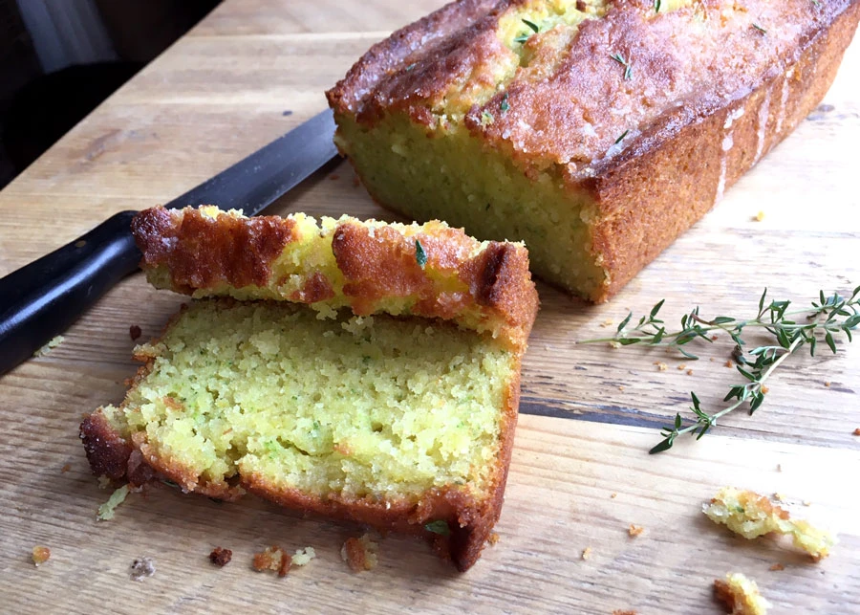
Ingredients:
For the cake:
- 200g self-raising flour
- 175g butter, softened
- 175g caster sugar
- 3 eggs
- 1 tsp baking powder
- 2 courgettes (approx. 250-300g total weight), grated
- 5 sprigs thyme, leaves picked
- zest of 1 lemon
For the drizzle:
- juice of 1 lemon
- 60g granulated or caster sugar
- 2-3 sprigs of thyme, leaves picked
Method
- Pre-heat the oven to 180c
- Grease/line a standard sized loaf tin
- Put the flour, butter, eggs, baking powder and sugar into a mixer and mix well.
- Turn the mixture out into a mixing bowl and add the lemon zest, grated courgettes, and thyme leaves. Mix with a wooden spoon.
- Pour the mixture into the loaf tin and put into the oven for 25-35 minutes until the top is golden and a skewer comes out clean when prodded into the centre.
- Once cooked, remove from the oven, and leave in the tin for 5 mins to cool.
- Remove cake from tin and place on a cooling rack.
- While the cake is cooling, mix the lemon juice, sugar, and remaining thyme leaves in a bowl.
- While the cake is still a little warm, pour the drizzle over the top.
- Wait until completely cool for the topping to crunch up and then tuck in!
Recipe from Farmhouse Recipes brought to you

