Fennel and Lemon Risotto
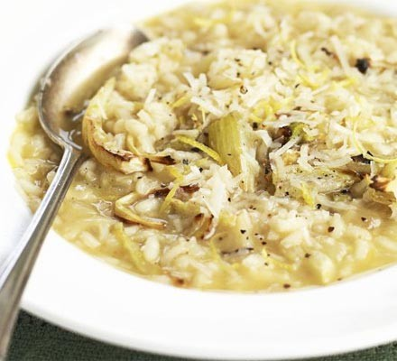
1 large fennel bulb, base trimmed
1 tbsp butter, plus a knob
1 onion, finely chopped
1 garlic clove, finely chopped
140g risotto rice
175ml white wine
550ml hot vegetable stock
zest 1 lemon
25g parmesan or vegetarian alternative, grated
STEP 1 Chop any green leafy fennel fronds and set aside. Cut off the stalk-like fennel top, remove the outer layers and finely chop both. Heat 1 tbsp butter in a frying pan and cook the onion, garlic and chopped fennel until soft but not coloured.
STEP 2 Add the rice and stir for 1 min. Pour over most of the wine and simmer until evaporated. Add 500ml of the hot stock, a ladleful at a time, stirring between each addition until it is absorbed.
STEP 3 Meanwhile, slice remaining fennel and fry in knob of butter until browned. Add remaining stock and wine and cook until tender.
STEP 4 When the rice is cooked, stir in the zest, Parmesan, and some seasoning. Take off the heat and set aside, covered, for 2 mins. Serve in bowls, topped with the fennel fronds and cooked fennel, stirring the prawns through if using.

Recipe from BBC Good Food brought to you by

